create table Doctor(

Doc_ID varchar2(5) primary key CHECK(Doc_ID like 'D%' and length(Doc_ID)=5),

Doc_Name varchar2(25) not null,

Gender char(1) not null,

DOB date not null,

Specialist varchar2(25) not null CHECK(Specialist in ('Neurology','Diabetes','Ophthalmology','Cardiology','General medicine')),

Qualification varchar2(25) not null CHECK(Qualification in ('MBBS', 'MS', 'MD', 'BDS', 'MDS')),

Contact number(10) not null,

Address varchar2(30) not null,

Dept_No varchar2(4) not null

);

create table Department(

Dept_No varchar2(5) primary key CHECK(Dept_No like 'D%' and length(Dept_No)=4),

Dept_Name char(20) not null CHECK(Dept_Name in('Cardiology','Intensive care unit','Neurology','Oncology','Obstetrics and gynaecology','Diabetes')),

Dept_Room_No number(4) not null,

Dept_Floor number(2) not null,

Dept_HOD varchar2(10) not null,

Dept_Estd_Date date not null CHECK(Dept_Estd_Date > '01-Jan-2010')

);

create table Staff(

Staff_ID varchar2(5) primary key not null CHECK(Staff_ID like 'S%' and length(Staff_ID)=5),

Staff_Name varchar2(20) not null,

Categoryy varchar2(20) not null check(Categoryy in ('Nurse','Lab Technician','Attender','Helper')),

dob date,

Contact number(10) not null,

Address varchar2(100),

Dept_No varchar2(4),

Designation varchar2(100) not null check (Designation in ('Staff Nurse','Head Nurse','Technician','Senior Attender','Junior Attender'))

);

create table Patient(

Pat_ID varchar2(5) primary key check( Pat_ID like 'PT%' and length(Pat_ID)=5),

Pat_Name varchar2(25) not null,

DOB date not null,

Gender char(1) not null check(Gender in ('M','F','T')),

Contact number(10) not null,

Address varchar2(30) not null

);

create table In_Patient(

Pat_ID varchar2(5) not null,

Date_of_admission date not null,

Bed_No number(4) not null,

Start_Time timestamp not null,

End_Time timestamp not null,

CHECK(Start_Time BETWEEN Date_of_admission AND End_Time)

);

create table In_Patient_Prescription(

Pat_ID varchar2(5) not null CHECK( Pat_ID like 'PT%' and length(Pat_ID)=5),

Pres_ID varchar2(7) not null CHECK(Pres_ID like 'PR%' and length(Pres_ID)=7)

);

create table Appointment(

App_ID varchar2(5) primary key CHECK( App_ID like 'APP%' and length(App_ID)=5),

Pat_ID varchar2(5) not null,

Doc_ID varchar2(5) not null CHECK(Doc_id like 'D%' and length(Doc_ID)=5),

Nurse_ID varchar2(5) not null,

Consult_Room_No number(4) not null,

Date_ date not null,

time_ timestamp not null

);

create table Prescription(

Pres_ID varchar2(7) primary key CHECK(Pres_ID like 'PR%' and length(Pres_ID)=7),

App_ID varchar2(5) CHECK( App_ID like 'APP%' and length(App_ID)=5),

Date_ date not null,

time_ timestamp not null,

Diagnosis_Detail varchar(30) not null

);

create table Prescribed_Medicines(

Pres_ID varchar2(7) CHECK(Pres_ID like 'PR%' and length(Pres_ID)=7),

Medicine_Name varchar2(15) not null,

Dosage varchar2(15) not null,

Brand varchar2(15) not null

);

create table Hospital_Bill(

Inv_No varchar2(6) unique,

Inv_Date date not null,

Pat_ID varchar2(5) CHECK(Pat_ID like 'PT%' and length(Pat_ID)=5),

Bill_Amount number(8) not null,

Payment_Type varchar2(15) not null,

discount number(2) not null

);

create table Lab_Tests(

Test_ID varchar2(5) primary key CHECK(Test_ID like 'TI%' and length(Test_ID)=5),

Pat_ID varchar2(5) CHECK( Pat_ID like 'PT%' and length(Pat_ID)=5),

Date_ date not null,

time_ timestamp not null

);

create table Test_results(

Test_ID varchar2(5) primary key CHECK(Test_ID like 'TI%' and length(Test_ID)=5),

TT_ID varchar2(5) CHECK( TT_ID like 'TT%' and length(TT_ID)=5),

Result varchar2(10) not null

);

create table Test_Types(

TT_ID varchar2(5) primary key CHECK( TT_ID like 'TT%' and length(TT_ID)=5),

Description varchar2(20) not null CHECK(Description in('Blood test','Urine test','Ultrasound test','Biopsy')),

Low_value number(4) not null,

High_value number(4) not null,

Test_method varchar2(15) not null,

Technician varchar2(5) not null

);

insert into Doctor values('D0001','Vibhu Kumar Singh','M','01-Jan-1990','Neurology','MBBS',8529759229,'Vasundhara','D102');

insert into Doctor values('D0002','Lionel Messi','F','02-Jan-1990','Ophthalmology','MD',8529759230,'Ghaziabad','D102');

insert into Doctor values('D0003','Akansha Sharma','F','03-Jan-1990','Cardiology','MDS',8529759231,'Kavi Nagar','D100');

insert into Doctor values('D0004','Sanjay Kumar','M','01-Jan-1990','General medicine','MBBS',8529759232,'Shastri Nagar','D103');

insert into Doctor values('D0005','Zaheer Khan','M','01-Jan-1990','Neurology','BDS',8529759233,'South Delhi','D102');

insert into Department values('D102','Cardiology',1001,01,'D0001','1-Jan-2020');

insert into Department values('D100','Intensive care unit',1002,01,'D0002','2-Jan-2020');

insert into Department values('D101','Neurology',1003,03,'D0003','3-Jan-2020');

insert into Department values('D103','Oncology',1004,04,'D0004','4-Jan-2020');

insert into Department values('D190','Diabetes',1005,05,'D0005','5-Jan-2020');

insert into Staff values('S0005','Sania','Nurse','01-Jan-1990',1234567892,'Jhotwara','D102','Staff Nurse');

insert into Staff values('S0001','Sam','Lab Technician','02-Jan-1990',1234567893,'Jaipur','D102','Technician');

insert into Staff values('S0002','Ramesh','Attender','03-Jan-1990',1234567894,'Jaisalmer','D100','Junior Attender');

insert into Staff values('S0003','Suresh','Nurse','04-Jan-1990',1234567895,'Goa','D101','Staff Nurse');

insert into Staff values('S0004','Manju','Nurse','05-Jan-1990',1234567891,'Pakistan','D190','Junior Attender');

insert into Patient values('PT001','Sam','01-Jan-2000','M',8529759249,'Thane West');

insert into Patient values('PT002','mary','02-Jan-2000','F',8529759257,'Thane East');

insert into Patient values('PT003','Kevin','03-Jan-2000','M',8340613668,'Chennai');

insert into Patient values('PT004','Jay','04-Jan-2000','M',8529659228,'Borivali West');

insert into Patient values('PT005','Nancy','05-Jan-2000','F',8526759234,'Worli');

insert into In_Patient values('PT001','01-Jan-2020',1010,to_timestamp('2020-11-03:08:49:01','YYYY-MM-DD HH24:MI:SS'),to_timestamp('2020-11-03:09:49:01','YYYY-MM-DD:HH24:MI:SS'));

insert into In_Patient values('PT002','02-Jan-2020',1012,to_timestamp('2020-10-04:09:34:01','YYYY-MM-DD:HH24:MI:SS'),to_timestamp('2020-10-04:11:34:01','YYYY-MM-DD:HH24:MI:SS'));

insert into In_Patient values('PT001','03-Jan-2020',1013,to_timestamp('2020-04-11:10:23:01','YYYY-MM-DD:HH24:MI:SS'),to_timestamp('2020-04-11:12:23:01','YYYY-MM-DD:HH24:MI:SS'));

insert into In_Patient values('PT004','04-Jan-2020',1014,to_timestamp('2020-06-20:11:55:01','YYYY-MM-DD:HH24:MI:SS'),to_timestamp('2020-06-20:13:55:01','YYYY-MM-DD:HH24:MI:SS'));

insert into In_Patient values('PT005','05-Jan-2020',1015,to_timestamp('2020-05-07:07:23:01','YYYY-MM-DD:HH24:MI:SS'),to_timestamp('2020-05-07:09:23:01','YYYY-MM-DD:HH24:MI:SS'));

insert into In_Patient values('PT004','01-May-2020',100,to_timestamp('2020-11-03:08:49:01','YYYY-MM-DD HH24:MI:SS'),to_timestamp('2020-11-03:09:49:01','YYYY-MM-DD:HH24:MI:SS'));

insert into In_Patient values('PT002','01-May-2020',100,to_timestamp('2020-11-03:08:49:20','YYYY-MM-DD HH24:MI:SS'),to_timestamp('2020-11-03:09:49:01','YYYY-MM-DD:HH24:MI:SS'));

insert into In_Patient_Prescription values('PT001','PR00001');

insert into In_Patient_Prescription values('PT002','PR00002');

insert into In_Patient_Prescription values('PT003','PR00003');

insert into In_Patient_Prescription values('PT004','PR00012');

insert into In_Patient_Prescription values('PT005','PR00005');

insert into Appointment values('APP01','PT001','D0001','S0003',111,'01-Jan-2020',to_timestamp('2020-11-01:09:49:01','YYYY-MM-DD:HH24:MI:SS'));

insert into Appointment values('APP02','PT002','D0002','S0005',111,'02-Jan-2020',to_timestamp('2020-10-22:11:30:01','YYYY-MM-DD:HH24:MI:SS'));

insert into Appointment values('APP03','PT003','D0003','S0005',111,'03-Jan-2020',to_timestamp('2020-04-13:08:49:01','YYYY-MM-DD:HH24:MI:SS'));

insert into Appointment values('APP04','PT004','D0004','S0003',112,'04-Jan-2020',to_timestamp('2020-06-23:12:34:01','YYYY-MM-DD:HH24:MI:SS'));

insert into Appointment values('APP05','PT005','D0005','S0003',113,'05-Jan-2020',to_timestamp('2020-05-16:13:40:01','YYYY-MM-DD:HH24:MI:SS'));

insert into Appointment values('APP06','PT003','D0001','S0003',111,'11-Jan-2020',to_timestamp('2020-11-01:09:49:01','YYYY-MM-DD:HH24:MI:SS'));

insert into Appointment values('APP07','PT002','D0001','S0003',111,'11-Jan-2020',to_timestamp('2020-11-01:09:49:01','YYYY-MM-DD:HH24:MI:SS'));

insert into Prescription values('PR00001','APP01','01-Jan-2020',to_timestamp('2020-11-01:09:49:01','YYYY-MM-DD:HH24:MI:SS'),'High BP');

insert into Prescription values('PR00002','APP02','02-Jan-2020',to_timestamp('2020-10-22:11:30:01','YYYY-MM-DD:HH24:MI:SS'),'Low Vitamins');

insert into Prescription values('PR00003','APP03','03-Jan-2020',to_timestamp('2020-04-13:08:49:01','YYYY-MM-DD:HH24:MI:SS'),'Low Bone Density');

insert into Prescription values('PR00012','APP04','04-Jan-2020',to_timestamp('2020-06-23:12:34:01','YYYY-MM-DD:HH24:MI:SS'),'Anaemia');

insert into Prescription values('PR00005','APP05','05-Jan-2020',to_timestamp('2020-05-16:13:40:01','YYYY-MM-DD:HH24:MI:SS'),'Fracture');

insert into Prescribed_medicines values('PR00001','crocin','10mg','Hamway');

insert into Prescribed_medicines values('PR00002','Combiflame','15mg','Hamway');

insert into Prescribed_medicines values('PR00003','SHA256','10ml','HDM');

insert into Prescribed_medicines values('PR00012','SHA1','20ml','HDM');

insert into Prescribed_medicines values('PR00005','SHA128','15ml','Hamway');

insert into Hospital_Bill values('4072','01-Jan-2020','PT001',150000,'cash',5);

insert into Hospital_Bill values('4073','02-Jan-2020','PT002',200000,'credit card',10);

insert into Hospital_Bill values('4074','03-Jan-2020','PT003',40000,'debit card',5);

insert into Hospital_Bill values('4075','04-Jan-2020','PT004',3000,'cash',10);

insert into Hospital_Bill values('4078','05-Jan-2020','PT005',5000,'debit card',15);

insert into Lab_tests values('TI001','PT001','01-Jan-2020',to_timestamp('2020-11-03:08:49:01','YYYY-MM-DD:HH24:MI:SS'));

insert into Lab_tests values('TI002','PT002','02-Jan-2020',to_timestamp('2020-10-04:09:34:01','YYYY-MM-DD:HH24:MI:SS'));

insert into Lab_tests values('TI003','PT003','03-Jan-2020',to_timestamp('2020-04-11:10:23:01','YYYY-MM-DD:HH24:MI:SS'));

insert into Lab_tests values('TI004','PT004','04-Jan-2020',to_timestamp('2020-06-20:11:55:01','YYYY-MM-DD:HH24:MI:SS'));

insert into Lab_tests values('TI005','PT005','05-Jan-2020',to_timestamp('2020-05-07:07:23:01','YYYY-MM-DD:HH24:MI:SS'));

insert into Test_results values('TI001','TT001','Positive');

insert into Test_results values('TI002','TT002','Positive');

insert into Test_results values('TI003','TT003','Negative');

insert into Test_results values('TI004','TT004','Negative');

insert into Test_results values('TI005','TT005','Positive');

insert into Test_Types values('TT001','Blood test',26,66,'Blood sample','S0004');

insert into Test_Types values('TT002','Blood test',23,65,'Blood sample','S0004');

insert into Test_Types values('TT003','Urine test',30,74,'Urine sample','S0004');

insert into Test_Types values('TT004','Urine test',11,23,'Urine sample','S0004');

insert into Test_Types values('TT005','Urine test',15,24,'Urine sample','S0004');

alter table Doctor add constraint fk_Doc_Dept_No foreign key(Dept_No) references Department(Dept_No);

alter table Department add constraint fk_Dept_HOD foreign key(Dept_HOD) references Doctor(Doc_ID);

alter table Staff add constraint fk_S_Dept_No foreign key(Dept_No) references Department(Dept_No);

alter table In_Patient add constraint fk_In_Pat_ID foreign key(Pat_ID) references Patient(Pat_ID);

alter table In_Patient_Prescription add constraint fk_InP_Pat_ID foreign key(Pat_ID) references Patient(Pat_ID);

alter table In_Patient_Prescription add constraint fk_InP_Pres_ID foreign key(Pres_ID) references Prescription(Pres_ID);

alter table Appointment add constraint fk_App_Pat_ID foreign key(Pat_ID) references Patient(Pat_ID);

alter table Appointment add constraint fk_App_Doc_ID foreign key(Doc_ID) references Doctor(Doc_ID);

alter table Appointment add constraint fk_App_Nurse_ID foreign key(Nurse_ID) references Staff(Staff_ID);

alter table Prescription add constraint fk_Pres_App_ID foreign key(App_ID) references Appointment(App_ID);

alter table Prescribed_Medicines add constraint fk_PresM_Pres_ID foreign key(Pres_ID) references Prescription(Pres_ID);

alter table Hospital_Bill add constraint fk_Hospital_Pat_ID foreign key(Pat_ID) references Patient(Pat_ID);

alter table Lab_Tests add constraint fk_Lab_Pat_ID foreign key(Pat_ID) references Patient(Pat_ID);

alter table Test_Results add constraint fk_TestR_Test_ID foreign key(Test_ID) references Lab_Tests(Test_ID);

alter table Test_Results add constraint fk_TestR_TT_ID foreign key(TT_ID) references Test_Types(TT_ID);

alter table Test_Results add constraint fk_TestR_Tech foreign key(Technician) references Staff(Staff_ID);  
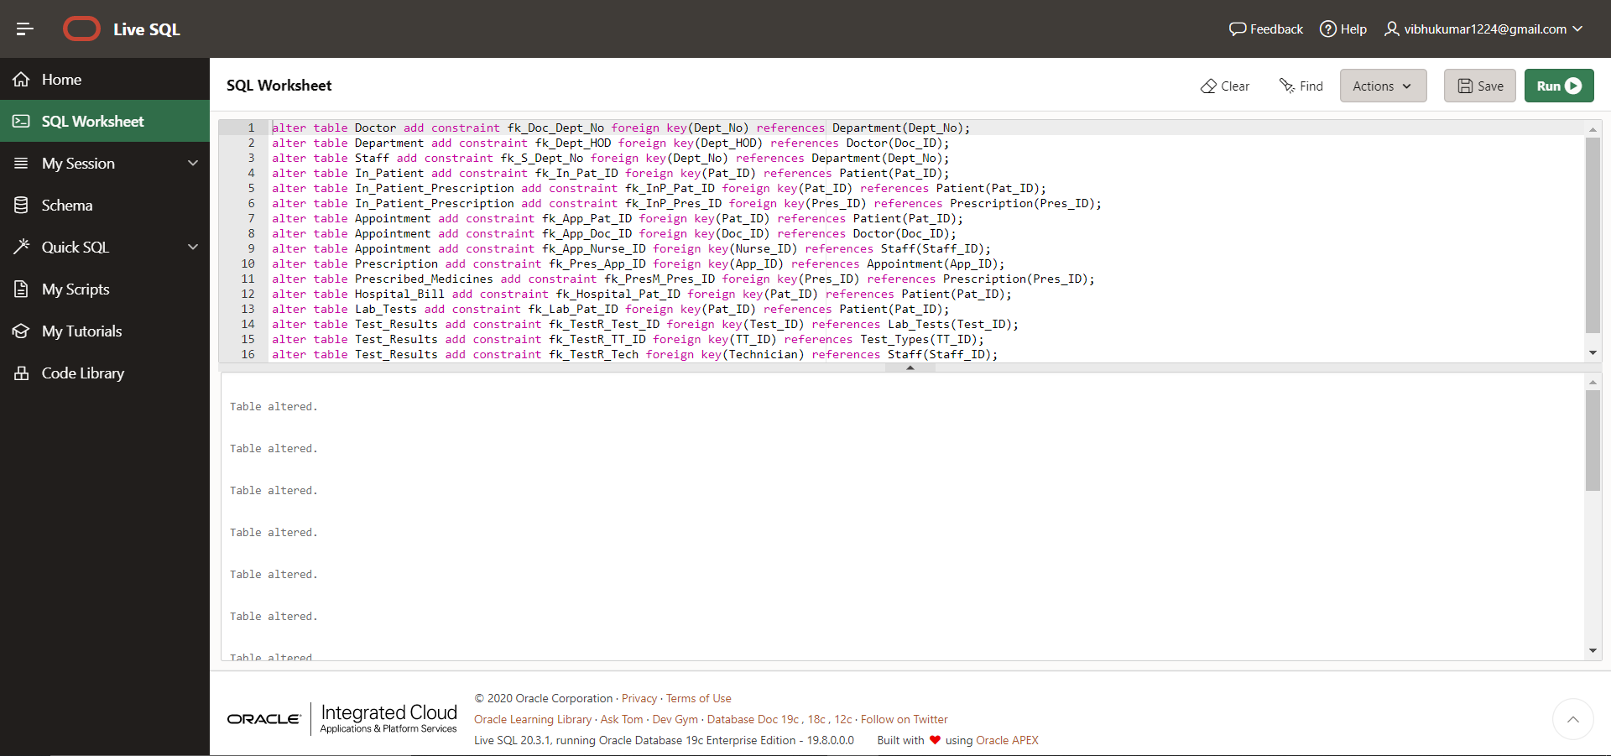

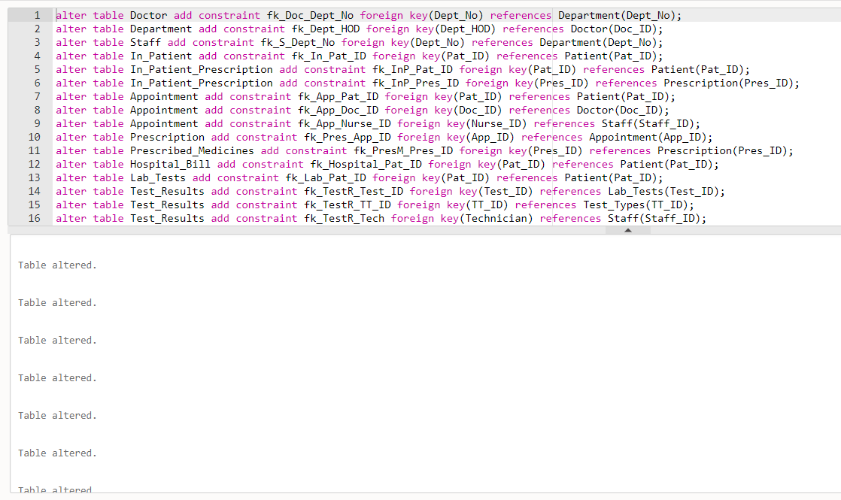

1. select Dept_HOD from Department, Doctor where Department.Dept_No = Doctor.Dept_No and Doc_Name = 'Raghavan';

select h.Dept_HOD from Department h inner join Doctor d on d.Dept_No = h.Dept_No where d.Doc_Name = 'Raghavan';

1. select Pat_Name from Patient,In_Patient where Patient.Pat_ID = In_Patient.Pat_ID and Bed_No = 'B101';

select distinct p.Pat_Name from Patient p inner join In_Patient i on p.Pat_ID = i.Pat_ID and i.Bed_No = 'B101';

**DDL statements (ALTER, CONSTRAINT etc):**

Q1)

alter table Hospital_Bill add consulting_physician varchar2(5);

alter table Hospital_Bill add constraint fk_con_physician foreign key(consulting_physician) references Doctor(Doc_ID);

Q2)

alter table Patient drop column Address;

alter table Patient add Street varchar2(15);

alter table Patient add City varchar2(15);

alter table Patient add Pincode number(6);

Q3)

alter table Patient add Test_Time varchar2(15);

alter table Patient add constraint ck_Test_Time check(Test_Time in (‘Before Food’,’After Food’));

Q4)

alter table Patient drop constraint ck_Test_Time;

Q5)

alter table Staff drop column Address;

alter table Staff add Door_No number(5);

alter table Staff add Street varchar2(15);

alter table Staff add City varchar2(15);

alter table Staff add Pincode number(6);

Q6)

create table Medicines(

Medicine_Name varchar2(15) primary key,

Brand varchar2(15) not null,

Dosage varchar2(15) not null,

Manufacture date not null,

Expiry date not null,

constraint ck_Manu_date check(Manufacture < Expiry)

);

Q7)

alter table Prescribed_Medicines drop column Dosage;

alter table Prescribed_Medicines drop column Brand;

alter table Prescribed_Medicines add constraint fk_Medicine_Name foreign key(Medicine_Name) references Medicines(Medicine_Name);

Q8)

create view Cardiology_Doctors as select Doc_ID, Doc_Name, Gender from Doctor where specialist = 'Cardiology';

Q9)

alter table Department add No_of_Staff number(2);

alter table Department add constraint ck_No_of_Staff check(No_of_Staff > 0);

Q10)

alter table In_Patient_Prescription add Room_Type varchar2(8);

alter table In_Patient_Prescription add constraint ck_Room_Type check(Room_Type = 'AC' or Room_Type = 'Non-AC');

**SQL queries with JOIN operation**

**Q1)**